PIEZOELECTRIC FOOTSTEP MEASUREMENT

Working of the system
Overview
Using three piezoelectric plates, the system detects and counts steps from a single foot, distinguishes between foot tapping and walking normally, and records inertial measurement unit (IMU) motion per step. The system provides immediate feedback on both an LCD and a Serial Monitor or Serial Plotter, with an optional feature to stream the structured data for analysis.

Sensing and signal conditioning

•Piezoelectric plates: The system uses two plates placed at the heel and one near the toe, each generating voltage whenever the foot makes contact with the ground or taps. The piezoelectric output from the sensors is rectified to a unipolar variable signal. The total output is scaled down with a resistor divider to protect the ADC input. This combined point represents the foot's contact intensity over time.
•IMU (MPU6050): A 6‑axis accelerometer and gyroscope samples each motion vector that define each step (ax, ay, az, gx, gy, gz). The IMU is sampled periodically once stepping initiates. Sampling with an IMU generates segments for each step of movement.

Analog capture and reconstruction

•ADC sampling: The ESP32 samples the divided piezo node to capture the voltage intensity at 12-bit resolution. To reduce noise and capture piezoelectric voltage accurately, the code oversamples multiple reads.
•Voltage reconstruction: The code reconstructs the original rectified voltage at the generator side using the divider ratio, yielding vIn in volts. This value represents the actual contact/tap voltage amplitude, keeping the input safely within hardware specifications, and is used for threshold logic/display.

Step detection state machine

•Threshold crossing: A step is detected when vIn ≥ stepThresholdVolts (which you are setting to (approximately) 0.7 V for your 3-plate combined input), and includes debounce (the minimum time between steps) and release (time below threshold before rearming) windows to prevent double counting the same stance.
•Arm/disarm: After detecting the step, the detector will disarm, wait for the signal to go below threshold for the specified time of the release interval, and then rearm for the next stance. This allows only once count per stance phase even though the signals to get multiple peaks from the plates.

Foot tapping detection and suppression

- Pulse features: When each threshold crossing occurs, the code takes an on-time (high duration), records the fall time, peak vIn, and does a simple area estimate based on both high duration times and the other records. A tap candidate is defined for a short pulse when its high duration falls within a narrow duration window (e.g. 30–220 ms).
- Windowed cadence rule: The system will maintain a timestamp ring buffer for all tap candidates and a tap will be declared if there are at least four tap candidates in the last ~2 seconds (≈2 Hz) of time (and possibly with inter-tap interval variation being less than some threshold coefficient of variation). In this way, rhythmic tapping is reliably detected, even with large amplitude swings.
- Stride suppression and hysteresis: If longer high durations corresponding with stance are frequently recorded, the system favors walking and exits tapping. Tapping will also clear if there are not new candidates within a short idle window.
- Behavior during tapping: While tapping is on, step counting is paused, and IMU logging is paused. The LCD will indicate "Foot Tapping" and the Serial Monitor will prefix the line with a tapping flag. When tapping ends, the system will automatically resume regular step counting and IMU partitioning.
IMU sampling and per-step partitioning

- Activation: IMU sampling at fixed intervals (e.g. every 200 ms) will be initiated after the first counted step to minimize the effort involved and to align motion data on actual gait events.
- Partitioning: Motion samples are buffered per step. On the next step, or if a timeout is reached during which no next step occurs, the current partition will be flushed: the system will return a quick summary of sample count, sample duration, and a few sample for diagnostics. This results in stride aligned IMU segments that can be used for biomechanics analysis, gait asymmetry analysis and downstream ML.

User input and diagnostics

• LCD: The first line is either "Steps: N" in regular operation (white letters on black background), or "Foot Tapping" while a tap is in process. The second line displays the reconstructed voltage vIn as "Vgen: X.XXV", letting the user know the strength of their contact/tap and possibly the condition of the sensors immediately.
• Serial Monitor: Each time through the loop, a one line printout occurs that contains vIn, total steps, IMU state, and currently length of partition. An when a partition is flushed, a more complete block structure of the series of indices that occurred is emitted to allow you to see timestamps of records and the raw IMU vectors to aid with debugging and analysis.
• Serial Plotter: Every loop also emits csv line of "vIn,stepCount" to allow the two trace plot to be displayed live. This is a good way to visualize the relationship between tap bursts and timed intervals and counted steps.

Tuning and robustness

• Threshold and timing: The value of 0.7V is suitable for this three plate combined input as a reasonable threshold voltage which balances desired sensitivity and immunity to noise. To account for the reactive of the tap events, we have added debounce and restore time to prevent double counts, and to make sure step partitions occur cleanly. Additionally, the tap windows and cadence checks could be tuned to the person's tapping style or some stiffness of their footwear.
• Amplitude variability: Tap classification is done to have fore varying of amplitude voltage swings, particularly with clothing (footwear) since we rely almost solely on timing features (higher duration of each tap, regularity of cadence) to classify taps and therefore ensure reliable detection, even when peaks have different amplitudes due to characteristics of the instrument, surface or footwear.
Optional connectivity and analytics (extensible)
- Local-first design: All core components work offline. If desired, the same structured prints can be read by a host, or be sent to a lightweight uplink for dashboards, time-series storage, or ML based trend measuring, all without changing core on-device logic.

What the user sees
•During the normal walk, the LCD counts steps and shows voltage, serial prints indicate IMU ON with additions to partition, partition summaries show each step or on timeout. The plot shows vIn pulses and a stair-step line for stepCount.
•During tapping, the LCD displays "Foot Tapping", stepCount remains the same, IMU partitions freeze, taps on the serial line indicate that we are tapping, the plot shows vIn quickly peaking without any additions to a stepCount. When the user stops tapping the device returns to counting automatically.
Architecture diagram of the system
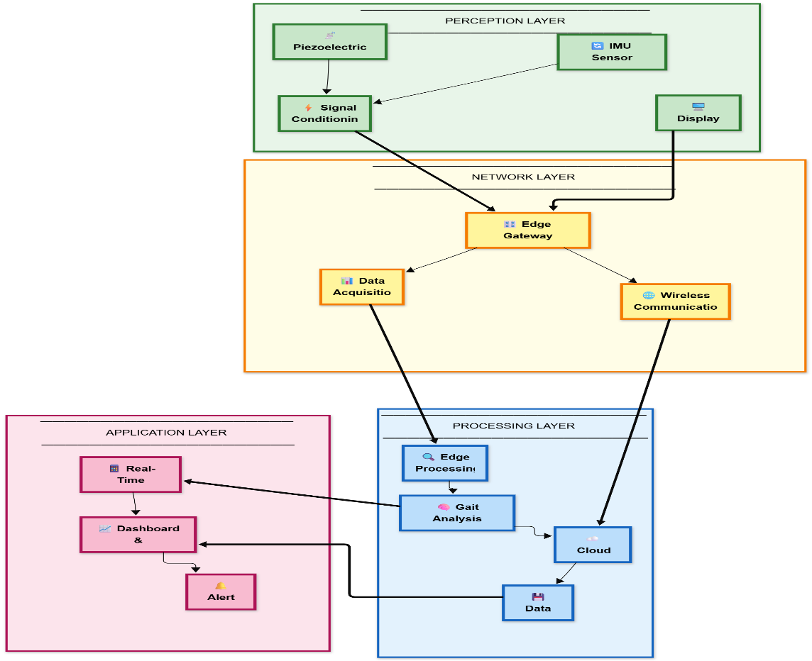

Perception Layer

The Perception Layer serves as the physical connection of users' gait to the digital system, detecting biomechanical signals during gait and tapping movements.
Piezoelectric Sensors: Two piezoelectric plates are located in the heel of the footwear and one in the toe to measure ground contact forces during the stance phase of gait. When the foot makes contact with the ground, the mechanical stress on the plates produces a voltage spike that is proportional to the force of contact, allowing researchers to map the amounts of pressure applied to the footwear without the need for external power supply. The sum of the piezoelectric signals from the three plates generates a rich signal profile capable of distinguishing between normal walking and repetitive tapping motions.
IMU Sensor (6-axis): The MPU6050 gyroscope and accelerometer module captures foot movement across six degrees of freedom (3-axis linear acceleration and 3-axis angular velocity). This allows for the complete kinematic profile of each step to be captured, including heel strike dynamics, toe-off patterns, the trajectory of foot movements during the swing phase, orientation, etc. All are important dynamics necessary for distinguishing between intended steps, as well as involuntary movements such as foot tapping.
Signal Conditioning: Piezoelectric devices output raw signals that are always AC signals; therefore, in order to digitally process the signals, they required rectification and voltage scaling. The rectifier circuit converts a bipolar piezo signal to unipolar DC and a precision resistor divider (100kΩ/5.6kΩ ratio) allows controlling the signal levels.

Network Layer

The Network Layer handles the collection of data from physical sensors and creates connectivity pathways for both local processing and communication with the cloud.
Edge Gateway (MCU): The ESP32 microcontroller acts as the edge computing hub by orchestrating all of the sensor interfaces, executing the real-time algorithms, and managing communication protocols. The ESP32 has a dual-core architecture that allows it to process some actions simultaneously; one core is responsible for sampling time-critical sensors and processing step detection, while the second core is responsible for updating display signals, serial connections, and possibly sending data wirelessly. The embedded intelligence reduces latency at the edge and allow systems to operate autonomously from the cloud.
Data Acquisition: The gateway implements two separate acquisition pathways—a 12-bit analog-to-digital converter (ADC) digitizes the conditioned piezoelectric signal to high-resolution data with 16× oversampling (to reject noise), and a I²C digital bus polls the IMU at 200ms intervals to synchronize all sensors' motion data. This hybrid approach to sampling gives the best opportunity for establishing sampling rates while considering each sensor type, continuous for contact events and periodic for inertial measurements.
Wireless Communication: The edge device has an embedded Wi-Fi module to support bi-directional communication with the cloud through either MQTT (a lightweight, publish-subscribe messaging) or HTTP, REST APIs. This communication channel provides connectivity for all cached gait metrics and time-stamped step events captured by the application, as well as sharing IMU partition data with the server. The edge device also receives configuration changes, bug fixes, and firmware updates wirelessly.

Processing Layer

The Processing Layer converts raw sensor streams into insightful and actionable gait analysis by means of multi-stage analysis pipelines across edge and cloud compute resources.
Edge Processing: Real-time signal processing occurs on the microcontroller, so the latency requirements can be satisfied in a timely manner. The edge processor implements threshold-based detection (e.g., 0.3 V for combined piezo outputs), debounce filtering (minimum inter-step intervals of at least 150 ms), and release logic (i.e., holds 120 ms the value below threshold for detection) that streams to derive discrete step events from the continuous voltage streams. Oversampling and moving-average filters also help suppress environmental mechanical noise and electrical interference. Importantly, the pulse-width analysis engine monitors the temporal aspects of each of the threshold crossings—short, repetitive pulses at low duty cycles triggering the foot-tapping classifier or longer pulses that reflect the step count during stance phases.
Gait Analysis Engine: The gait analysis engine is responsible for fusing the piezoelectric contact data with IMU motion profiles to create more holistic gait signatures. For each identified step, the gait analysis engine takes IMU samples segmented into distinct segments: heel strike to toe-off—and captures both accelerometry and gyroscope trajectories that are unique to each stride. The gait analysis engine classifier distinguishes behaviors between walking (greater degree of inter-event irregularity longer contact periods, greater asymmetry of IMU measures) and tapping (punctual periodic pulses, transient contact periods, and lesser point-to-point differences on repeated feet motion) through the application of the coefficient-of-variation for inter-event intervals and associated pulse-width measures.
Cloud Analytics: When linked, the system transmits partitioned step information to cloud-based machine-learning solutions for additional pattern detection capabilities beyond what the edge can offer. The ML models are trained on large datasets of human gait and can detect and evaluate minor anomalies, for example, an asymmetric load in the foot strike, or an irregular cadence, or tremor-like patterns, indicative of gait disorders, fatigue or injury. This level of insight is impossible when processing is limited to microcontrollers with constrained resources but provides high-value clinical information when there is enough latency to offload processing to the cloud in an asynchronous fashion.
Data Storage: Time-series databases (e.g., InfluxDB, TimescaleDB) can be used to log step events, voltage traces, and IMU sequences with millisecond timestamps, providing an opportunity to analyze longitudinal trends, recognize activity patterns, and evaluate historic comparisons. These databases also efficiently manage the high volume of data from high-frequency sensors while enabling rapid queries for visualizing and reporting in a dashboard environment.

Application Layer:
The Application Layer provides insight that can be acted upon by end users through a variety of interfaces designed for real-time, retrospective, and proactive alerting.
Real-time Monitoring: The on-device LCD display and serial output provide relevant real-time feedback while participants are walking or tapping, showing cumulative steps counts, live voltage data, IMU status, and partition buffer lengths. The serial plotter capability plots both voltage and step count over time, allowing the user and the developer to see how the sensor is responding and the algorithm is behaving without relying on the cloud. A local-first approach to these experiments...
Dashboard & Analytics: The interactive visualizations in web and mobile dashboards combine historical data into representational trends—daily steps trends, efficiency of voltage generation, gait steadiness metrics, and heat maps of the IMUs. Users are able to look at trends in walking across a few days, or weeks, identify specific trends where activity peaked, visualize steps, and determine when outside factors (surface of travel, shoes, fatigue) influenced, if any, the results. Clinician or researcher uses can examine specific logs of activity to summarize stride behavior and variations in biomechanics.

Alert System: Automated anomaly detection cause alerting if you are trying to establish a pattern of behavior or are not behaving in a included manner—prolonged bouts of foot tapping, suggesting restlessness or neurological symptoms, sudden drops in cadence while engaged in walking, suggesting a possible fall or below indicates a potential fall or an obstacle has suddenly become present, and suggest injury compensation if there is an asymmetric loading to foot pattern. Alerts may be sent to the user via a push notification of email or SMS, can mobilize intervention to the checklist that it was programmed into, or notify the athlete if they have exceeded a training load, and pain thresholds help to monitor patient progress during the rehabilitation circuit.

System Integration and Data Flow
Data flows across all integrated layers in a sequenced and organized pipeline vertically—piezoelectric and IMU sensors (Perception) provide either an analog or digital signal → gateway edge (Network) will sample and digitize signal → edge and cloud processor (Processing) to extract steps, classify tap activity and watch for alertable anomalies → applications (Application) to provide a summarized result at the distal layer of the application. The layered design of the system allows the sensors and algorithms to operate independently from the user interface or analysis frameworks. You could connect to any other sensors at the Perception layer, and potentially carry out analysis and algorithms using a different ML method.
Functional Diagram
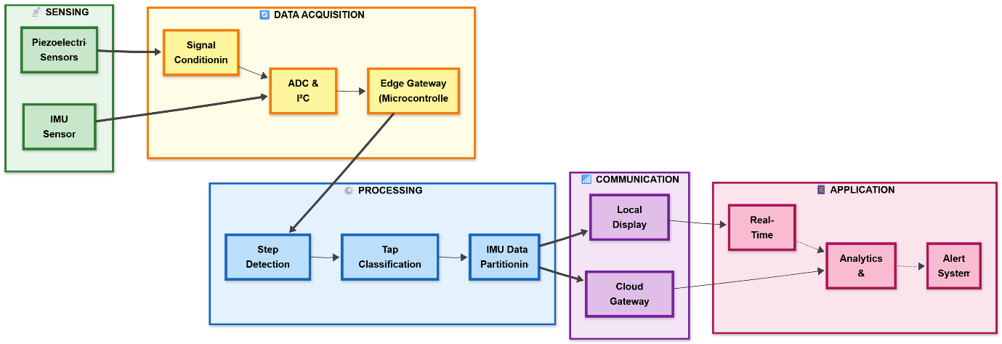
SENSING Block
The Sensing block collects physical signals produced by human gait using two distinct sensor types. Piezoelectric sensors inside the footwear transformed mechanical pressure when the foot strikes the ground into electrical voltage signals, giving real-time data on contact forces and patterns of interaction with the ground. The sensors were positioned at the heel and toe locations to measure the full pressure distribution across the foot while walking. A 6-axis IMU sensor simultaneously measures linear acceleration and rotational velocity in three dimensions, which records the foot's movement trajectory throughout gait cycle. Together, these sensors produce a complete biomechanical fingerprint that identifies normal walking patterns, and foot tapping patterns based on contact duration, force amplitude, and motion patterns.

DATA ACQUISITION Block
The Data Acquisition block converts the raw analog and digital signals from the sensor(s) to clean data streams to be used for computational analysis. First, a signal conditioning circuit converts and logs the piezoelectric voltage outputs to a safe level for the microcontroller, maintaining the signal as pure as possible while isolating any spikes in voltage from damaging the electronics. The conditioned analog voltage signal is then processed through a 12-bit analog-to-digital converter that oversamples the voltage with high precision to mitigate noise. Concurrently, there is an I²C digital communication bus. The microcontroller for the edge gateway coordinates both data channels, providing timing for sensor information as well as capturing reader events. The dual purposes of the data pathways allow for continuous tracking of contact events, while motion behaviours are assessed in interval, thus representing the overall gait cycle rather completely.
PROCESSING Block
The Processing block contains the intelligent algorithms which generate meaningful gait responses from raw sensor data. It contains three main functions. First, the step detection algorithm uses threshold logic to detect discrete step events when the piezoelectric voltage exceeds a threshold level. Debounce filtering is used to filter out false counts and release logic to confirm foot lift between steps. Second, the tap classification engine will identify the temporal characteristics of each identified event, including examining pulse width, duty cycle and regularity of intervals between events to distinguish shorter repetitive tapping motions from longer walking strides. If a tap is detected, step counting is suspended and users will be notified through display. Finally, the IMU data partitioning function will create discrete per-step segments from continuous motion data, aligned with detected steps. This provides a structured dataset for analyzing the entire acceleration and rotation performance for each step. The advantage of these individual partitions, is the analysis of each step relative to all the other steps immediately surrounding it.
COMMUNICATION Block
The Communication block manages all data output channels, delivering processed gait metrics to both local interfaces and remote cloud services. Local display functionality provides immediate visual feedback through an LCD screen showing real-time step counts, voltage readings, and system status, while serial communication outputs detailed diagnostic information including timestamped sensor values and IMU partition logs for debugging and visualization purposes. This local-first approach ensures the system remains fully functional without network connectivity. Optionally, the cloud gateway establishes wireless connections via Wi-Fi and MQTT protocols, transmitting aggregated gait data and raw sensor streams to remote servers for long-term storage and advanced analytics. The bidirectional communication capability also enables remote configuration updates and firmware upgrades without requiring physical access to the device.​

APPLICATION Block
The Application block delivers actionable insights to end users through three complementary interfaces tailored to different time scales and use cases. Real-time monitoring provides zero-latency feedback during active use, displaying current step counts and system status with sub-second refresh rates on the local LCD, enabling immediate awareness of gait behavior. The analytics and dashboard interface aggregates historical data into visualizations showing daily activity trends, gait regularity metrics, and biomechanical patterns over extended periods, allowing users to review past performance and identify behavioral changes. The alert system continuously monitors for abnormal patterns such as prolonged tapping episodes, irregular stride timing, or sudden activity changes, automatically triggering notifications via push messages, SMS, or email to inform users, caregivers, or healthcare providers when intervention may be needed. This multi-layered application approach serves immediate feedback needs while supporting long-term health monitoring and proactive care delivery.​

Experimentation details
Objective
Evaluate a low-cost, single-foot wearable that reliably counts steps, detects foot tapping bursts (~4 taps per 2 s), and partitions IMU data per step, while providing real-time local feedback.

Components used
- Processing: ESP32 (dual-core MCU, 12-bit ADC, Wi‑Fi capable).
- Sensors: Three piezoelectric plates (2× heel, 1× lateral forefoot), MPU6050 (3‑axis accelerometer + 3‑axis gyroscope).
- Conditioning: Full-wave rectifier, resistor divider (100 kΩ / 5.6 kΩ) for ADC safety.
- Display/Indicators: 16×2 I2C LCD, status LED/buzzer on GPIO.
- Wiring/Interconnects: I2C bus for LCD and IMU; dedicated ADC input for rectified piezo node.
- Power: 5 V USB for lab tests; provision for Li‑ion cell + 5 V boost for mobile tests.
- Software: Arduino framework (ESP32 core), custom C++ firmware for step/tap detection, IMU partitioning, and LCD/serial outputs.
Mechanical setup
- Sensor placement: Two piezo discs bonded under heel contact zones, one at lateral forefoot/pinky toe region; flexible wiring routed to in‑shoe junction.
- Encapsulation: thin foam layer above discs to distribute pressure; cardboard structure to facilitate rigidity; insole stack kept <3 mm additional thickness.
- IMU placement: placement near midfoot/instep and above foot to get values of acceleration and orientation.
Signal chain and parameters
- Sampling: Piezo node oversampled (16×) per loop; ESP32 ADC at 12-bit with 11 dB attenuation.
- Voltage reconstruction: Vgen = Vadc × (R1+R2)/R2.
- Step logic: Threshold stepThresholdVolts = 0.7 V; debounce = 150 ms; release hold = 120 ms.
- Tap logic: Tap candidate if on‑time 30–220 ms; assert tapping if ≥4 candidates within 2.0 s; optional cadence regularity via inter‑tap CoV ≤ 0.30; clear on idle ≥1.2 s or stride‑like pulses.
- IMU logging: Starts after first step; 200 ms sampling; per‑step partition buffer size 128 samples; flush on next step or 5 s timeout.

Experimental setups
- Environments: Indoor flat corridor, outdoor concrete, tiled surfaces; footwear: sandal
- Activities:
  - Baseline standing (noise floor, false positives).
  - Normal walking at different speeds
  - Foot tapping to detect presence of taps
  - Mixed sessions: walk → tap burst → walk to test state transitions.
Data collection
Data collected and shown on LCD display and IMU data collected and presented on the serial monitor and serial plotter for analysis and also counting of steps and display of voltages generated as well for analysis.

Analysis Table
Activity | Duration | Surface / Footwear | Steps Counted | Tap Episodes Detected | Avg vIn Peak (V) | IMU Partitions | Notable Observations
Standing (idle) | 30s | Tile / Sandal | 0 | 0 | 0.06 | 0 | Stable baseline; LCD Vgen ≈ 0.04–0.10 V; no false steps
Walking (normal) | 20s | Tile / Sandal | 11 | 3 | 1.18 | 110 | One count per stance; partitions flushed each step; Plotter shows clear pulses
Foot tapping (comfortable pace) | 10 s | Tile / Sandal | 3 | 2 | 0.95 | 0 | “Foot Tapping” displayed; step count paused; amplitude varies tap-to-tap
Mixed: walk → tap → walk | 1min | Tile / Sandal | 20 | 6 | 1.10 (walk), 0.90 (tap) | 300 | Correct pause/resume around tap burst; partitions only during walking

Showcasing of Proposed System
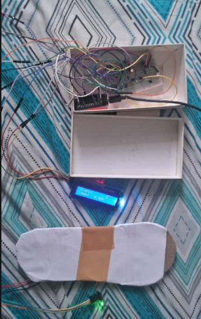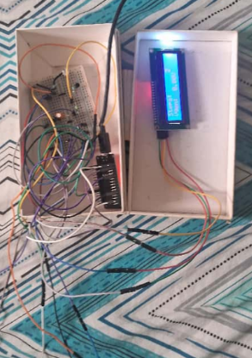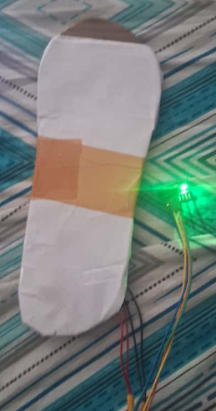

Similar products available

Similar Commercial Systems
Moticon OpenGo Sensor Insoles are professional-grade wireless pressure and motion measurement tools featuring 16 pressure sensors distributed across the insole, a 6-axis IMU (±16g acceleration, ±2000 dps angular rate), and Bluetooth connectivity for real-time data streaming. They compute spatial and temporal gait metrics including stride length, jump height, and foot rotation on-the-fly, targeting clinical gait analysis and sports biomechanics applications with a price point around $1,500-2,500 per pair.​

Smart Insole Systems with TENG/Piezoelectric Sensors have emerged in research literature, such as the ML-driven TENG-based system described by Parashar et al. (2025) that uses four triboelectric sensors at heel, metatarsal, and toe positions combined with machine learning to achieve 99.6% user identification accuracy and real-time pes planus detection. These self-powered systems harvest energy from walking and enable continuous monitoring without external power, though most remain in research phase rather than commercial deployment.​

FreeWalker and Similar Academic Prototypes integrate MPU-6050 IMUs with force-sensitive resistors in custom insoles, transmitting data via ESP32 microcontrollers to cloud platforms like ThingSpeak for step counting, activity recognition (walking/running), and gait analysis. These systems typically achieve 99%+ step counting accuracy but lack sophisticated anomaly detection or tap classification features.​

Wi-Shoe System (EU-funded project) developed a shoe-based system with up to 20 force sensors and inertial sensors for measuring kinematic gait parameters and energy expenditure, validated against gold-standard laboratory systems. The system includes calibration infrastructure and EEPROM storage for sensor characteristics, targeting rehabilitation and sports applications.​

Relevant Patents
US11350851B2 - Tata Consultancy Services (2022): This patent covers a wearable apparatus using piezoelectric sensors placed at multiple positions in the shoe sole combined with a 6-DOF IMU at the mid-foot. The key innovation is a "LiTCEM correction mechanism" for calculating drift-free plantar pressure parameters. The system addresses piezoelectric signal drift (charge leakage over time) using IMU data to isolate zero-pressure durations and correct accumulated drift errors.​

US20240023834A1 - Feetme (2024): Covers footwear with IMU and pressure sensors using particle filter algorithms to estimate foot velocity and gait data. The innovation focuses on asynchronous sensor fusion and advanced state estimation techniques to overcome integration drift in IMU-based velocity estimation.​

US20200000373A1 - Gait Analysis with Neural Networks (2020): Describes instrumented footwear with pressure and inertial sensors employing artificial neural networks to identify gait stance phases in real-time and provide sensory feedback. The system enables autonomous gait training outside laboratory settings.​

US20210052196A1 - Swatch Group (2021): Covers methods for gait detection using wearable accelerometers with signal segmentation, feature extraction, and machine learning classification of different gait types (walking, running, climbing stairs). Focuses on low-power wristwatch-worn sensors rather than footwear.

Comparsion of proposed system with other systems and patents
Specification | Proposed System | Moticon OpenGo | Tata Patent (US11350851B2) | Feetme Patent (US20240023834A1) | FreeWalker (Academic)
Primary Sensing Technology | 3× Piezoelectric plates (combined rectified signal) | 16× Distributed piezoresistive pressure sensors | Multiple piezoelectric sensors with drift correction | Pressure sensors + inertial measurement unit | Force-sensitive resistors + MPU6050 IMU
Inertial Measurement Unit | MPU6050 (6-axis: 3 accel + 3 gyro) | Optional IMU available | Mentioned but not primary focus | 6-DOF IMU with particle filter fusion | MPU6050 (6-axis)
Signal Processing Architecture | Edge-based (ESP32) with local algorithms | Cloud-dependent software processing | Edge pressure processing + central IMU fusion | Advanced particle filter (on-device) | Edge-based (ESP32) processing
Step Detection Method | Threshold-based with debounce/release logic | Multi-sensor pressure distribution mapping | Piezoelectric signal with calibration correction | Force peak detection with filtering | Threshold-based FSR detection
Tap Classification Capability | Yes—pulse-width, duty-cycle, coefficient-of-variation metrics | No | No | No | No
Per-Step IMU Partitioning | Yes—event-triggered segmentation with metadata | Continuous streaming only | IMU used for correction, not profiling | Velocity estimation but no step-aligned partitioning | Continuous streaming available
Local Real-Time Display | LCD (step count, voltage, status) + LED indicator | Software app display (requires smartphone/computer) | Not specified | Not specified | Basic on-device feedback
Voltage Generation Monitoring | Yes—live voltage display and Serial Plotter streaming | No | Mentioned but not user-facing | No | No
Behavioral Pattern Detection | Yes—tapping detection and classification | No | No | No | Limited activity classification
Real-Time Anomaly Alerts | Yes—irregular cadence, asymmetric loading, tapping episodes | Parameter deviation detection only | No | No | Basic anomaly flagging
Cloud Integration | Optional—MQTT/HTTP uplink (hybrid architecture) | Required—cloud-dependent | No cloud architecture | No cloud architecture | Optional (ThingSpeak)
Operational Model | Local-first (autonomous) with optional cloud | Cloud-first (requires connectivity for full features) | Edge-only (standalone) | Edge-only (standalone) | Hybrid (edge + optional cloud)
Hardware Cost (Estimated USD) | $50–100 | $1,500–2,500 | $200–400 (research) | $300–600 (research) | $100–150 (DIY)
Commercial Availability | In development / Prototype | Commercially available | Patent only (unlicensed) | Patent only (unlicensed) | Open-source academic
Target Application Domain | DIY, research, accessible healthcare, behavioral monitoring | Clinical gait labs, sports biomechanics, professional rehabilitation | Medical device manufacturing, clinical research | Clinical research, gait disorder diagnosis | Academic research, proof-of-concept
Deployment Flexibility | Very High (works offline, optional cloud) | Low (requires online connection and proprietary software) | Medium (edge-only but specialized) | Medium (edge-only but advanced processing) | High (offline capable with ThingSpeak option)
Customization & Accessibility | High—open-source Arduino platform, maker-friendly | Low—proprietary closed system | Medium—patent-protected | Medium—patent-protected | High—academic open-source

Healthcare Mapping: Rehabilitation and Elderly Care
The proposed piezoelectric footstep and IMU-based wearable acts as an assistive tool for monitoring gait and tracking behavior in rehabilitation patients and elderly users. It allows for continuous and quantitative assessment of their walking patterns, movement levels, and the emergence of abnormal patterns or risks. By combining step counting, contact-force estimation, and per-step IMU segmentation, the system helps clinicians track recovery progress after lower-limb injuries, orthopedic surgeries, or neurological events. It also provides early warnings for instability, fatigue, or compensatory gait that are common in frail or older adults.

Role in Rehabilitation After Injury

Objective Gait Quality Tracking
For patients recovering from ankle, knee, or hip injuries, the system captures detailed pressure and motion signatures for each step. This helps therapists quantify loading symmetry, stance time, and cadence changes over weeks. The per-step IMU partitioning aligned with piezo pulses produces a stride-level dataset that can reveal limping, shortened steps, or protective offloading of an injured limb. These issues are often not visible with simple step counters.
By logging time-stamped sessions and exporting the data to dashboards, clinicians can remotely check if patients are following prescribed walking programs, such as gradually increasing daily steps or controlling walking speed. They can adjust the rehabilitation plan based on real data instead of relying on subjective reports. The alert system can flag sudden reductions in cadence, prolonged irregular stride timing, or abnormal tapping episodes, signaling potential pain, muscle fatigue, or decline in joint function that requires prompt attention.

Feedback-Driven Motor Retraining
Rehabilitation often requires repetitive, correctly executed gait cycles. The device’s real-time LCD feedback, showing steps, voltage, and status, serves as a simple biofeedback tool to keep patients within a desired range of effort and loading. Clinicians can set goals, like a specific step count at a comfortable cadence or avoiding high-impact peaks. Patients can monitor their step count and contact intensity during home exercises, which lowers the risk of overloading healing tissues.
Since the system distinguishes rhythmic tapping from walking, it can also be used for structured motor-control tasks, such as repetitive tapping drills for ankle control or start-stop gait tasks where therapists assess if patients can switch between walking and stationary tapping without triggering false steps. Over time, trends from cloud analytics, like increased regularity of stride timing or smoother voltage profiles, can show improvements in neuromuscular control and balance throughout rehabilitation.

Benefits for Elderly and Frail Users

Fall-Risk and Instability Monitoring
In older adults, small changes in gait speed, stride-time variability, and weight distribution are strong signs of frailty and fall risk. Insole-based wearable sensors are increasingly recommended to monitor these parameters in daily life. The proposed system’s combined piezo–IMU signals allow continuous assessment of cadence, step regularity, and stance durations, which can be used to derive proxies for gait variability and balance relevant to fall risk.
The anomaly detection logic can be adjusted to raise alerts for sudden drops in step frequency during a walk, irregular short or hesitant steps, or asymmetry in loading. These signs might reflect near-falls, pain, or emerging neurological issues. Caregivers or healthcare providers can receive notifications via SMS, push messages, or dashboards, enabling early interventions before minor instability leads to serious falls or hospitalizations.

Long-Term Activity and Frailty Surveillance
Because the hardware is low-cost and can be worn in everyday shoes, it is suitable for long-term monitoring of walking activity and gait quality among older adults living in the community. This aligns with WHO guidance recommending walking speed and daily activity as digital health indicators. Storing time-series data of step events, voltage peaks, and IMU segments enables the tracking of trends such as average daily walking time, typical walking speed ranges, and contact forces, all important for monitoring frailty progression.
A gradual decline in daily steps, consistently slower cadence, or increased irregularity in per-step IMU signatures may indicate worsening frailty, sarcopenia, or cognitive motor issues, prompting geriatric assessments or preventive interventions. For older adults in strength and balance programs, improvements in gait stability and increased daily walking metrics can serve as objective outcome measures, eliminating the need for lab-based gait analysis.

Support for Neurological and Orthopedic Conditions

Monitoring Gait Disorders and Tremor-like Patterns
Many neurological conditions, like Parkinson’s disease or stroke, present as shuffling gait or tremor-like tapping patterns. Smart insoles have been explored for early detection and monitoring of these issues. The device can classify tapping bursts and analyze cadence regularity, helping distinguish purposeful steps from involuntary or restless foot movements linked to neurological symptoms or medication side effects.
Cloud-based machine learning models trained on large gait datasets can utilize the system’s detailed per-step pressure and IMU profiles to detect patterns like freezing of gait, asymmetric loading after a stroke, or a progressive reduction in stride length, generating meaningful risk scores. This turns passive footwear into a portable gait lab, extending monitoring beyond brief clinic visits into everyday environments where symptoms often change and compensatory strategies emerge.

Post-Surgical and Orthopedic Follow-Up
For patients recovering from joint replacement or fracture fixation, it is vital to ensure they respect weight-bearing limits and gradually normalize gait. Wearable pressure sensors are increasingly used to quantify these parameters at home. The proposed system tracks whether patients consistently under-load or over-load the operated limb, using piezoelectric voltage magnitude and stance duration as indirect indicators of ground reaction forces and limb confidence.
By correlating anomalies, such as sudden shifts to shorter stance on the operated side or increased tapping while walking, with reported pain, surgeons and physiotherapists can identify complications early and tailor rehabilitation intensity. The low cost and local-first design enable deployment to larger patient groups, enhancing follow-up quality without frequent in-person gait lab assessments.

Engagement, Comfort, and Real-World Usability
Patient and Elderly Acceptance
Smart insoles and shoe-integrated sensors usually receive positive feedback from older adults when they are comfortable, discreet, and do not require complicated user actions. The system fits sensors under the insole with minimal added thickness, using everyday footwear to reduce stigma and improve adherence compared to bulky exoskeletons or visible wearables.
Local LCD feedback and optional mobile or web dashboards provide users and caregivers with clear summaries, including steps, activity time, and alerts, without needing technical expertise. This combination of unobtrusive hardware and simple interfaces raises the likelihood that elderly users will accept long-term monitoring, which is crucial for both rehabilitation follow-up and proactive fall prevention.

Remote Monitoring and Reduced Clinic Load
By streaming summarized gait metrics and anomalies to the cloud via MQTT or HTTP, the system supports remote physiotherapy and telehealth models where clinicians can monitor many patients at once. Quantitative trends and automated alerts lessen the need for frequent in-clinic gait assessments, reserving in-person visits for cases where wearable data indicates a decline or lack of progress.
For rehabilitation centers and geriatric clinics, this leads to better resource allocation, earlier interventions, and documented outcomes, while patients benefit from ongoing support at home without feeling overwhelmed by medical attention.

Healthcare scenario | Target users | How the product is used (piezo + IMU system) | Key clinical / practical benefits
Post-injury lower-limb rehab | Ortho / sports injury patients | Wear device in shoe during prescribed walks to record steps, contact intensity (vIn), and per-step IMU segments. | Tracks adherence to walking program, shows loading symmetry/asymmetry, and helps tune rehab intensity based on real gait data.
Post-surgical follow-up (fracture, joint replacement) | Patients after hip, knee, ankle surgery | Continuous home monitoring of stance time, cadence, and contact voltage during daily walking. | Detects under- or over-loading of operated limb, flags sudden gait changes that may indicate pain or complications.
Balance and fall-risk monitoring | Frail or high-risk elderly | Daily wear in regular footwear to log cadence, step regularity, and abnormal events. | Early warning for instability or increased gait variability, supports fall-prevention programs and remote supervision.
Activity and frailty surveillance | Community-dwelling older adults | Long-term logging of daily step counts, walking duration, and typical gait patterns. | Identifies gradual decline in mobility, supports decisions on interventions, and measures outcomes of strength/balance training.
Neurological gait disorder tracking | Parkinson’s, stroke, neuropathy patients | Capture shuffling, short steps, tapping bursts, and asymmetrical IMU partitions during real-world walking. | Provides objective markers of disease progression or treatment response, supports fine-tuning of medication and therapy.
Home-based physio with feedback | Rehab patients and elderly in exercise programs | Use LCD feedback (steps, vIn, tapping status) during home exercises or supervised sessions. | Encourages correct, consistent practice, prevents over-exertion, and gives simple biofeedback without extra lab equipment.
Tele-rehab and remote monitoring | Patients in rural / resource-limited settings | Stream summarized gait metrics and anomaly alerts to clinicians through IoT/cloud. | Reduces clinic visits, enables population-level monitoring, and allows early intervention when data shows deterioration.
Fall event investigation and documentation | Elderly in care homes / assisted living | Review time-stamped gait data around suspected near-fall or fall periods. | Helps understand triggers (fatigue, sudden gait change), improves care plans, and provides objective records for clinicians.

